Customer Success Manager



🎯 Training Overview

Welcome to Your CSM Journey!

Congratulations on completing your foundational training! You're now entering the role-specific phase where you'll master the technical and strategic skills that make a world-class Customer Success Manager.

🎯 Your Mission as a CSM

As a Customer Success Manager, your role is built on 3 core pillars:

- Commercial: Manage renewals and expansion opportunities to drive merchant retention and revenue growth
- Service: Deliver exceptional support by managing tasks, business reviews (BRs), and WhatsApp group communications
- Feature: Educate merchants on StoreHub features to maximize product adoption and value realization
You'll use frameworks, scripts, and proven processes to handle conversations, overcome objections, and ensure merchants succeed with StoreHub.
You're not just managing accounts- you're driving merchant success through commercial growth, proactive service, and feature enablement.

You're not just managing accounts- you're driving retention and shaping StoreHub's future through merchant insights.

📅 Your 3-Day Journey Timeline

Foundation (Already Completed!)

Day 1-2: Generic Training
- ✅ All-in-One StoreHub Product Knowledge
- ✅ System Navigation & Merchant Profile Basics
- ✅ Hardware Demo & Foundational Quiz (20% of final score)

Specialization Begins Now
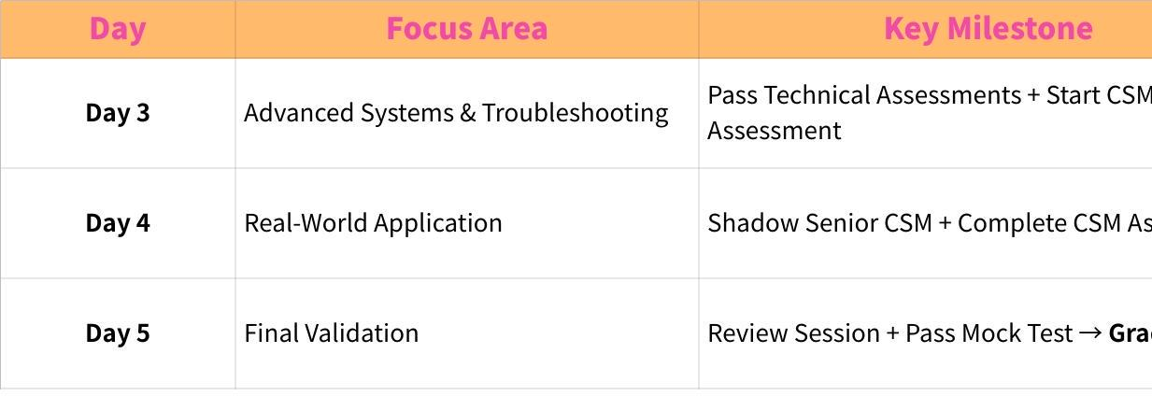
Click the image to view the sheet.

📅 Your Detailed Training Schedule

Day 3: Advanced Systems & Troubleshooting
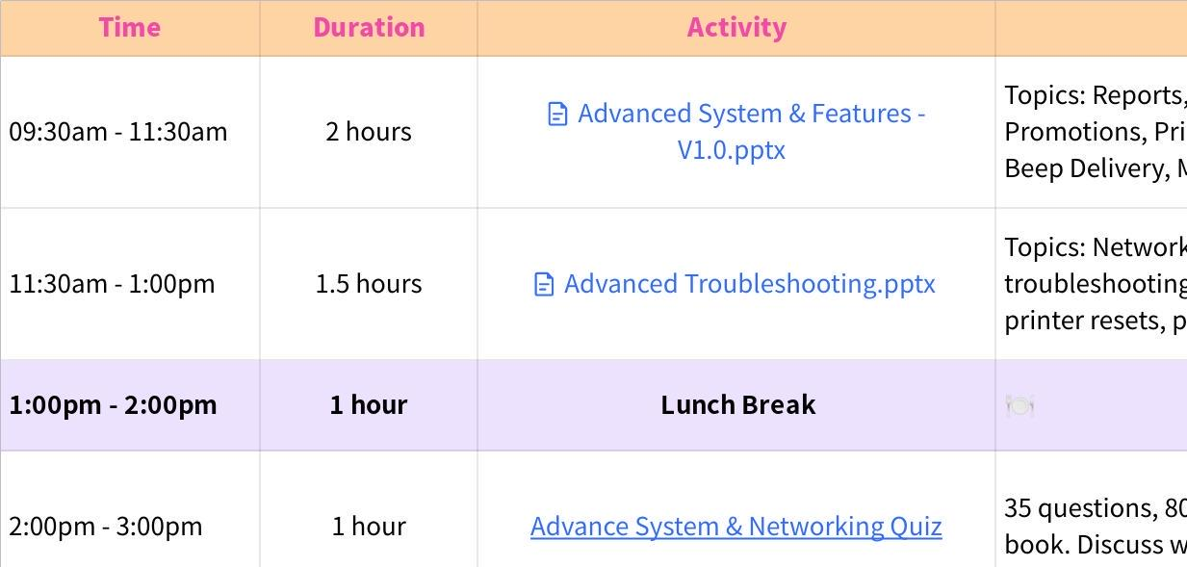
Click the image to view the sheet.

Day 4: Real-World Application & Assessment Work
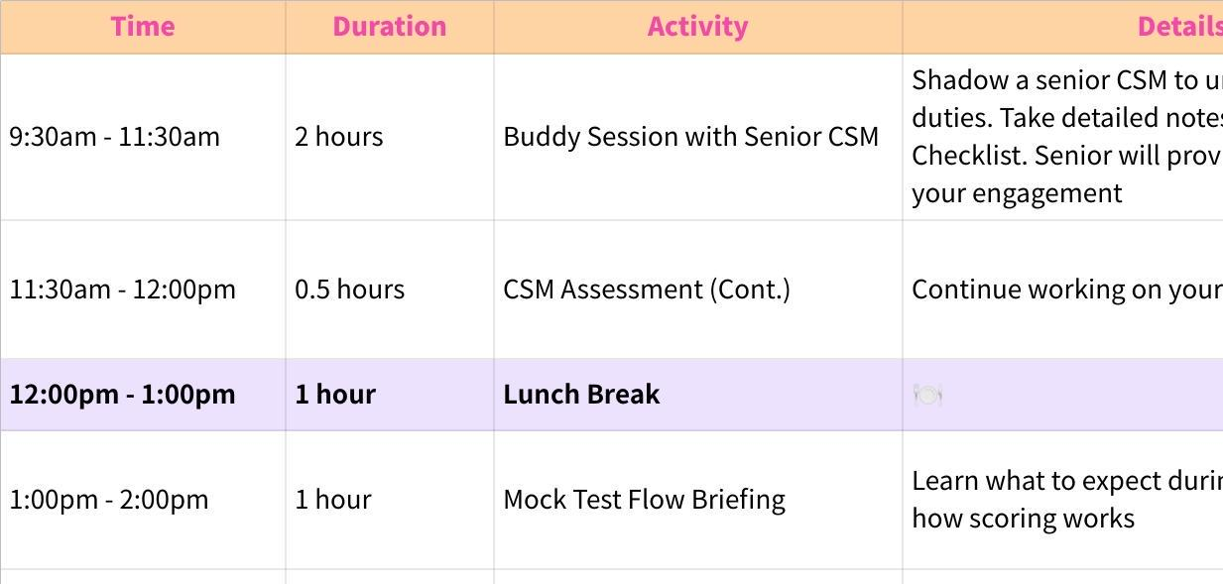
Click the image to view the sheet.

Day 5: Final Validation & Graduation
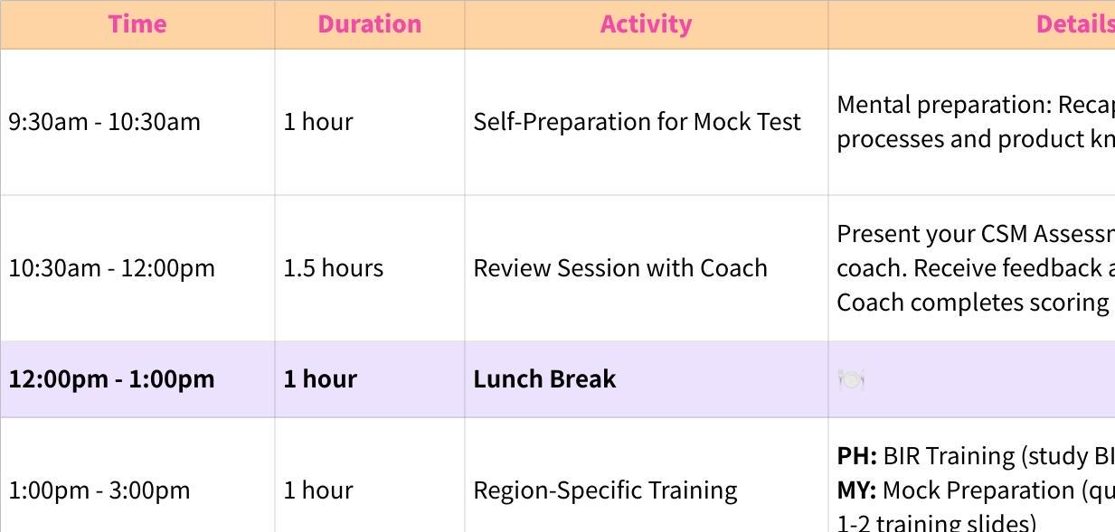
Click the image to view the sheet.

Milestones You'll Complete

Milestone 1: Advanced Systems Mastery (Day 3)

What You'll Learn:
- Advanced system features (reports, CSV import/export, promotions, pricebooks)
- Specialized features (QR Order & Pay, Beep Delivery, Membership, Engage)
- Networking fundamentals and printer troubleshooting (IP addresses, feed tests, printer configuration)

Assessments:
- Advance System & Networking Quiz (10% of final score)
- 35 questions, 80% passing score
- Open-book test using training slides
- No retakes- take your time and review carefully.

- Hardware Assessment (5% of final score)
- Live demonstration with your coach
- Scenarios include: hardware assembly, printer search, feed tests, resets, configuration, and IP troubleshooting
- 80% passing score required

By End of Day 3:
- Begin working on your CSM Assessment(instructions provided)

Milestone 2: Real-World Application (Day 4)

What You'll Do:
- Buddy Session with Senior CSM (2 hours)
- Shadow a senior CSM to understand daily duties
- Take detailed notes in the provided Buddy Checklist (Buddy Session! )
- Senior CSM will review your performance and leave feedback

Pro Tip: This is your chance to see theory in action- ask questions!

- Complete CSM Assessment (20% of final score)
- This is a strategic documentation task demonstrating your understanding
- Submit by end of Day 4 to your coach for review
- 80% passing score required

Why This Matters: The buddy session bridges classroom learning and real-world execution. Pay close attention- you'll be doing this independently soon!

Milestone 3: Final Validation (Day 5)

Morning: Review & Preparation
- Self-Prep Time: Mentally prepare by recapping role-specific processes and product knowledge
- Coach Review Session: Present your CSM Assessment to your coach and receive feedback

Afternoon: Mock Test (45% of final score - Your Biggest Assessment!)
- 2 rounds of live roleplay with your coach
- Spontaneous scenarios testing your technical problem-solving and customer communication
- 80% passing score required
- This is your moment to shine!

Graduation: Upon passing, you'll officially graduate training and transition to your Team Lead for full onboarding into your CSM role.

🎓 Your Complete Assessment Breakdown

Formal Assessments (80% Total)
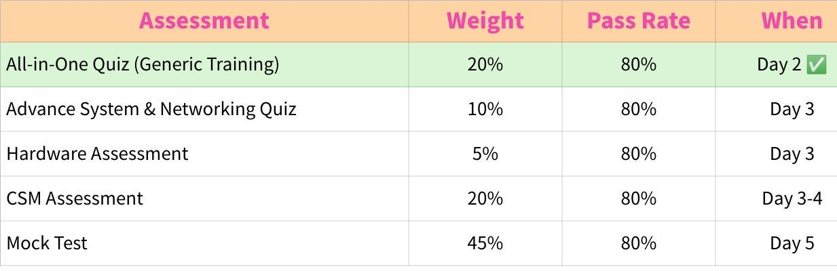
Click the image to view the sheet.
Formal Assessments Subtotal: 100%
Key Insight: The Mock Test carries the most weight because it demonstrates your ability to apply everything you've learned in real-time scenarios. Prepare thoroughly!

📊 Participation Score (5% - 20%)

Your active engagement throughout training is evaluated daily by your trainer and can add 5% to 20% to your overall score.

This means your true final score range is 0% - 120% (100% from assessments + up to 20% from participation).

How Participation is Scored

Your trainer evaluates you across 3 categories:
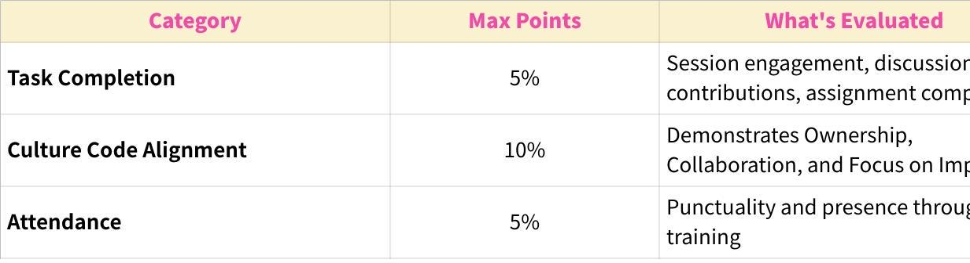
Click the image to view the sheet.
Participation Scoring Rubric
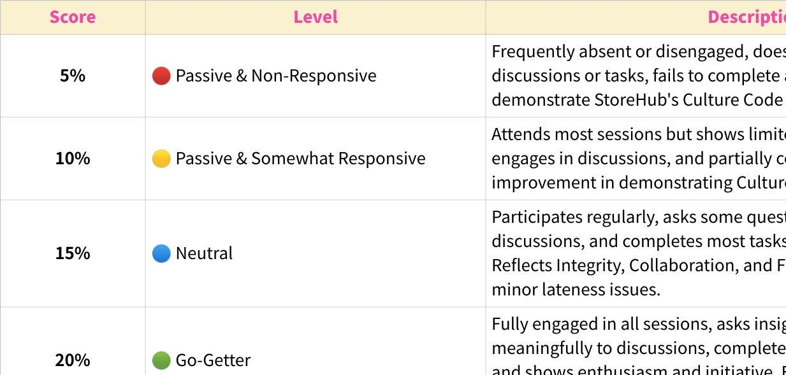
Click the image to view the sheet.
Attendance Policy
- Medical Leave (MC), Emergency Leave (EL), Unpaid Leave (UPL), or Immediate Family Bereavement are excused and do not negatively impact your attendance score
- Unexcused absences or chronic lateness will affect your participation score

Who Scores Participation?
Your trainer (Andrea) tracks your daily engagement and assigns your participation score at the end of training.

Pro Tips for Maximizing Your Participation Score:
- Be Present & Punctual - Show up on time, every time
- Engage Actively - Ask questions during sync-ups, share insights during buddy sessions
- Complete Tasks Thoroughly - Don't just finish assignments excel at them
- Update Daily - Proactively share your progress with your trainer by 6pm
- Embody Culture Code - Demonstrate ownership of your learning journey
- Help Your Peers - Collaboration is valued—support fellow trainees when appropriate
Remember: Participation isn't about being the loudest voice- it's about being consistently curious, accountable, and professional.

👥 Your Coach & Support System

Who is Your Coach?
Your coach (also referred to as your Team Lead) is assigned based on your country/region:

Click the image to view the sheet.
What Your Coach Does:
- Conducts your Hardware Assessment (Day 3)
- Reviews your CSM Assessment (Day 5)
- Administers your Mock Test (Day 5)
- Provides feedback and scores your performance
- Becomes your direct manager post-graduation

When to Reach Out:
- If you're stuck on training materials
- To schedule your review session (Day 5)
- For clarification on assessments

Trainer's Role:
- Coordinates scheduling between you and your coach
- Tracks your progress through the training program
- Available for logistical support (not technical content)

📚 Resources & Self-Study Tips

Your Training Materials
All slides and resources are provided in your training folder. Key materials include:
- Advanced System & Features - V1.0.pptx
- Advanced Troubleshooting.pptx
- [CSM] - Tools & Supply Chain.pptx
- Brand Servicing.pptx (homework Day 3)
- Buddy Session! (provided Day 4)
- CSM Assessment(provided Day 3)

Self-Study Best Practices
- Follow the schedule strictly- each module builds on the previous one
- Take notes- you'll reference them during open-book quizzes
- Update your trainer by 6:00pm daily on learning progress
- Don't hesitate to ask questions during sync-up sessions
- Prepare mentally for the Mock Test—practice explaining concepts out loud

Homework Policy
If you can't complete slides during working hours, finish them as homework. Day 3's homework is the Brand Servicing.pptx module.

🚀 Ready to Excel?
You've already proven yourself by passing the foundational training. Now it's time to specialize and become the technical expert merchants rely on.

Your Checklist:
- Review this overview thoroughly
- Ensure you have access to all training materials
- Confirm your coach assignment with your trainer
- Set up your Buddy Checklist access for Day 4
- Get ready to dive into Day 3 content!

Remember: This is a self-study journey, but you're never alone. Your coach, trainer, and senior buddies are here to support you every step of the way.

